

**Faculty of Engineering and Technology**

**Electrical and Computer Engineering Department**

**Designing of Room Themostat**

|  |  |
| --- | --- |
| **Name:** | **ID:** |

**Instructor:**

**TA:**

**Section:**

**Date:**

1

**Table of Contents:**

|  |  |  |
| --- | --- | --- |
| **1)** | **Abstract: ......................................................................................................** | **3** |
| **2)** | **Theory: ........................................................................................................** | **4** |
| **3)** | **Calculations : ....................................................****..............................................** | **6** |
| **4)** | **Simulations: ..........................................****..............................................................** | **9** |
| **5)** | **Final circuit diagram : ....................................................****...............................** | **13** |
| **6)** | **conclusion: ..........................................****.................................................................** | **13** |
| **7)** | **References: ..........................................****..................................................................** | **14** |
|  |  |  |

2

1. **Abstract:**

In this assignment we will use Orcad Pspice to design the room thermostat for the controlling of room temperature.The core componenets usedfor this project are the opeartional amplifier ua741 and temperatre sensor LM35 along with some basic components as resistors, transistors and power supplies.And the operationla amplifers are used in the form of diffrential amplifier.

3

1. **Theory:**

Nowadays the themostats are very common and useful thing to be used.It is the part of every electronic item starting from Air condition to the industrial heaters.These are available in many ranges in terms of prices and quality.It can be designed using different methods and components but in this project the major component is ua741 operational amplifer.And these two amplifers are conneted in such way that they are working as differtial amlifier.

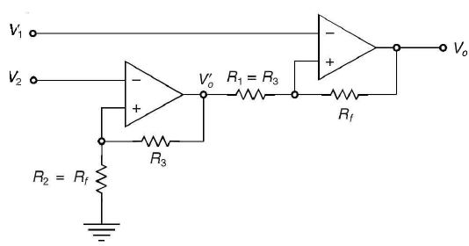

*Figure 1-Diagram of differential amplifier-*

The above diagram shows the construction of diffrentail amplifier which is the basic and prime componentof this circuit.The working of the whole circuit is divided into some steps which are these.

**Step 1:**

In this stage the lm35 which is analog temperature sensor and it sense the temperature and converts that temperature into respective volatge value

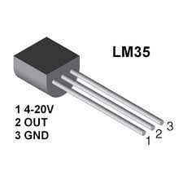

In other words it converts the temperature sensed into the form of voltage pulses.And the rate at which it converts is given below.

Vout= temperature* 10mV

For exapmle if we apply 8C to this sensor then the 80mv will be appeared on its output pin.Similary for 32C it will show 320mv on its output.

**Step 2:**

As the volatge appeared on the Vout of the LM35 then this volatge is applied to the diffrential amplifer and at this point the controlling is done and output is controlled with the help of resistors.The output of this differential amplifier is the responsible for the controling of the load.

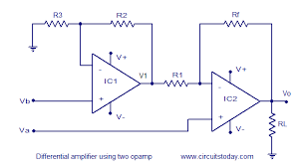

The values of resistors attached in the above figure decide the output voltage as vout.And the volage shown as Va and Vb are also used for the controlling of the output. RL is the load resistor and we can replace it with some load like fan, motor or Led.The calculation for these resistors will be described next.

**Step 3:**

In the last step the load is connected which we want to control according to our desire and we can attached that load dirrectly or using npn or pnp transistor. And the load can be Some Led, motor or heavy load connected with relay.

**3) Calculations:**

**Calculation for R1, R2 and R3**

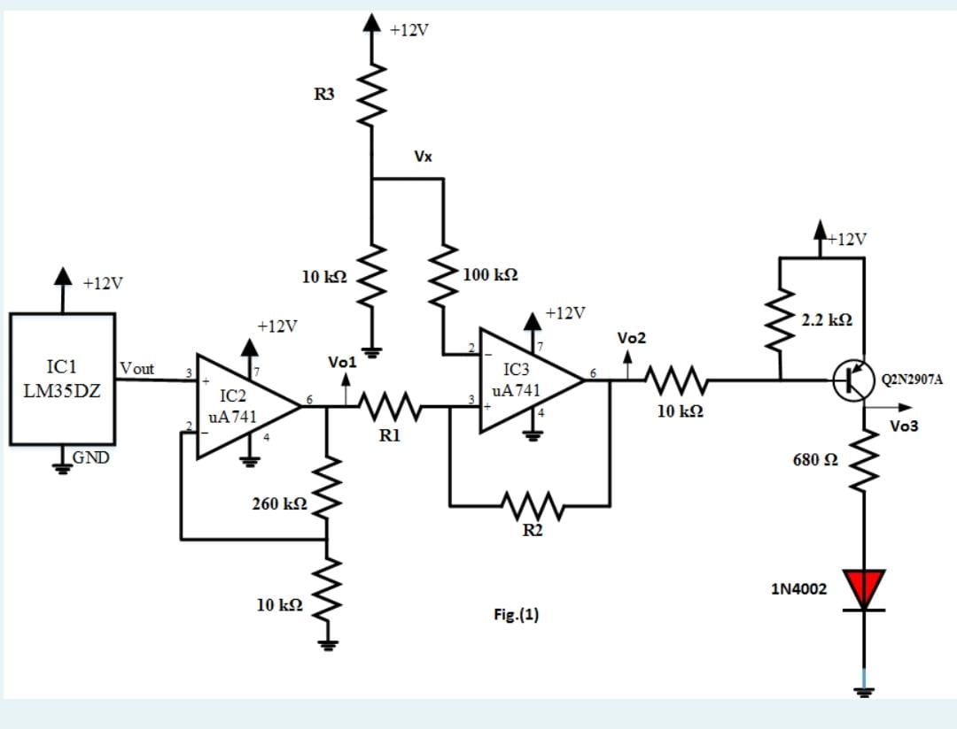

We have to find the values for R1, R2 and R3.

**Calculation for R3:**

In the above figure we can see that 10k resistor and R3 are making volatge divider with each other so the output volatge appeared the Vx point will be the result of the R3.Let 10k resistor is R2

So for R3 we can say that

Vx= (R2*Vin)/ (R2+R3)

Here the Vin is 12V so

Vx= (10k*12v)/ (10k+R3)

This Vx is applied at the input of 2nd amplifier using 100k resistor. So by changing the R3 the applied voltage will be changed.For example if we want to give voltage of 7.183 to the input of the 2nd amplifier then the value of the R3 should be

7.183=120k/ (10k+R3)

(10k+R3)= 120k/ 7.183

10k+R3=16.70k

R3=16.70k-10k

R3=6.70k

So the value of the R3 should be 6.70K.

**Calculation for R1 and R2:**

The value of vo1 is the output of the first amplifier and we know that the first amplifier is working as the non invertiong so the calculation for this is that

Vo1= [1+ (260k/10k)]*Vout

Vo1= [1+26]*Vout

**Vo1=27*Vout**

So for **14C** the Vo1 is

Vo1=27*140mv

Vo1=3.7V

So for **16C** the Vo1 is

Vo1=27*160mv

Vo1=4.3V

So for **8C** the Vo1 is

Vo1=27*80mv

Vo1=2.181V

So for **32C** the Vo1 is

Vo1=27*320mv

Vo1=8.6V

As we know that for diffrencialamplifier eqtations are

Figure shows the schematic diagram of a differential amplifier with two OP Amps



                   The output V'o, due to the first stage is:

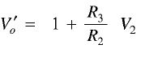                  ........... (1)

Using Superposition theorem to the second state having V1 and V'o, the output voltage Vo can be written as:

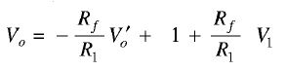

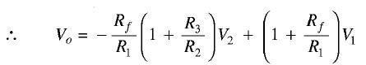      ........... (2)

Since R1 = R3 and Rf = R2, therefore,

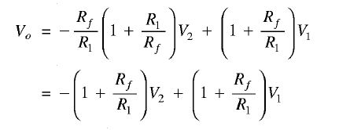

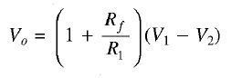                          .............. (3)

So lloking at the quation two we can say that if we want our desired output and value of the Vo1 is constant then the R1 and R2 can be calculated.

**Calculation For TL=14C**

Vo= (-R2/R1)Vo1+ (1+R2/R1)V1

At 14C we know that Vout will be 140mA and the value of the output should be 0.4 so that transistor can turn on.

Let R2=10k and R1=20k

0.4= (-10k/20k)Vo1+ (1+10k/20k)V1

As at 14C Vo1=3.80v so

0.4=(-0.5*3.80)+(1.5*V1)

0.4=-1.9+1.5*V1

V1=1.53

AS we know that

V1=Vx-7.98mv

1.53= [R2/(R2+R3)]*12 – 7.98mV

1.53798= [10k/(10k+R3)]*12

1.53798/12=10k/(10k+R3)

0.1281=10k/(10k+R3)

10k+R3=10k/0.1281

R3=78.06k-10k

R3=68.06k

So the values should be R3=68.06k R2=10k and R1=20k

**Calculation For TH=16C**

Vo= (-R2/R1)Vo1+ (1+R2/R1)V1

At 16C we know that Vout will be 160mA and the value of the output should be 11.6 so that transistor can turn off.

Let R2=10k and R1=20k

11.6= (-10k/20k)Vo1+ (1+10k/20k)V1

As at 14C Vo1=4.341v so

11.6=(-0.5*4.341)+(1.5*V1)

11.6=-2.1705+1.5*V1

V1=9.180

AS we know that

V1=Vx-7.98mv

9.18798= [R2/(R2+R3)]*12 – 7.98mV

9.18798= [10k/(10k+R3)]*12

9.18798/12=10k/(10k+R3)

0.7856=10k/(10k+R3)

10k+R3=10k/0.7856

R3=12.72k-10k

R3=2.72k

So the values should be R3=2.72k R2=10k and R1=20k

**4) Simulations:**

**Simulation of Stage 1:**

**For 16C Vout=4.346**

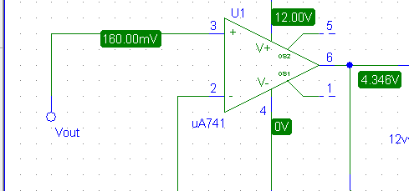

**For 14C Vout=3.80**

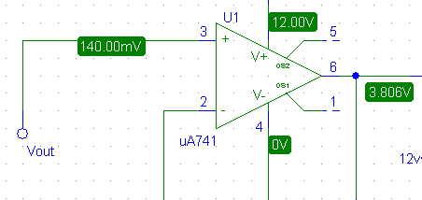

**Simulation of Stage 2:**

**For 14C Vo2=386.27mv**

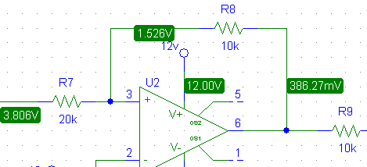

It means that at this temertaurethe trasistor will turn on and the heater will start heating.

**For 16C Vo2=11.6V**

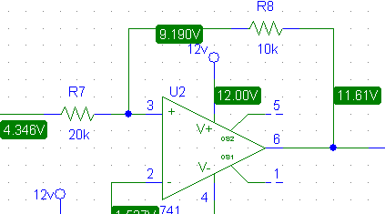

It means that at this temertaurethe trasistor will turn off and the heater will stop heating.

**Simulation of Stage 3:**

**For 16C Vo2=11.6v**

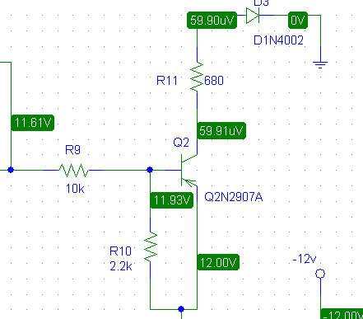

At this temperature the final output is 59.91uv the transistor is off and heater is also off.

**For 14C Vo2=386.27v**

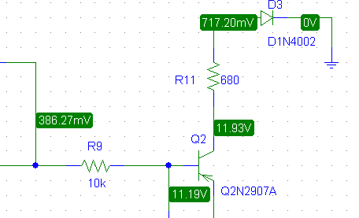

At this temperature the final output is 11.93v the transistor is on and heater is also on.

**Values of Vx,Vo1,Vo2,Vo3, Transistor and Diode:**

**At 8C:**

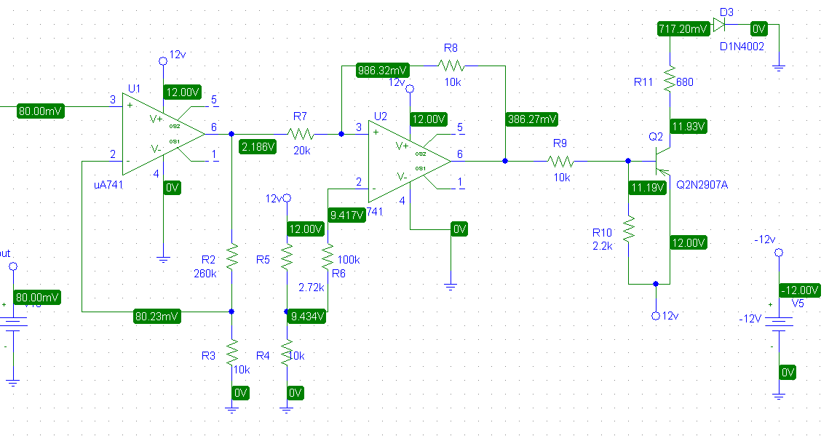

At 8C the values are:

Vout=80mv

Vo1=2.186

Vo2=386.27mv

Vo3=11.93V

At diode=717.20mv

Vx=9.434

And the heater is on.

**At 32C:**

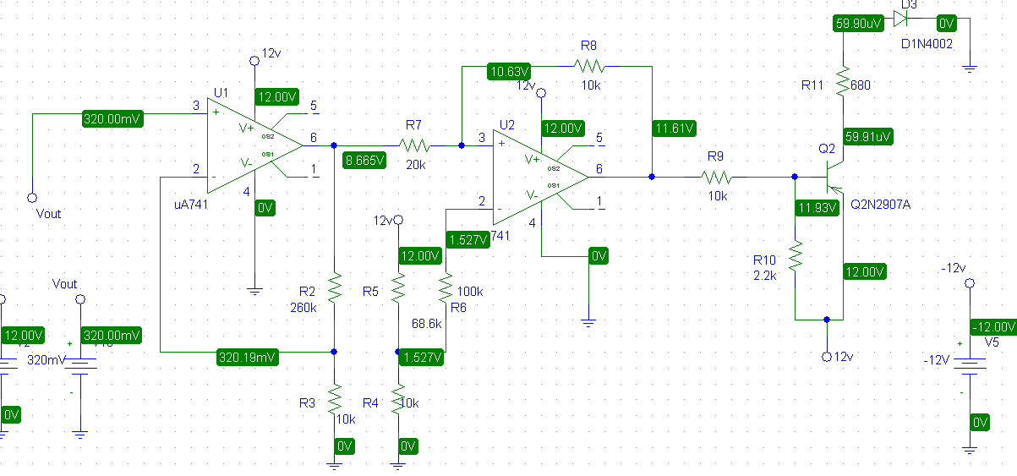

At 32C the values are:

Vout=320mv

Vo1=8.665V

Vo2=11.61V

Vo3=59.91mv

At diode=59.90uv

Vx=1.527V

**Ploat of Vo2(t) for 8 to 32V:**

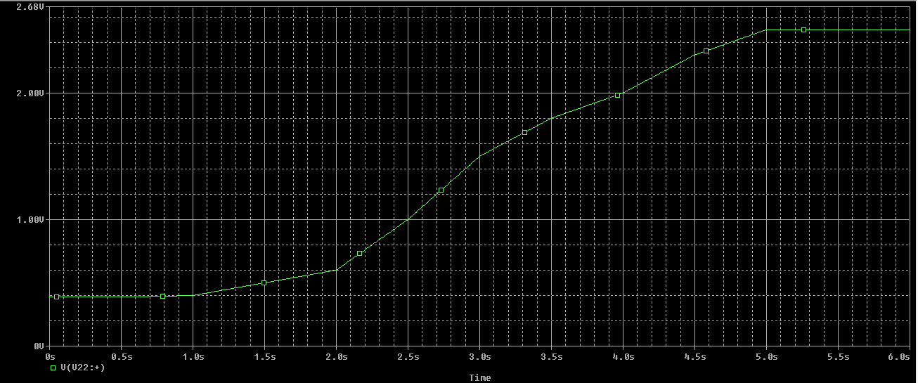

As the temperature increasese the output volatge at Vo2 increase and this increasing volatge is responsible for turning off the transistor and heater.

**Ploat of Vo2(t) for 32 to 8V:**

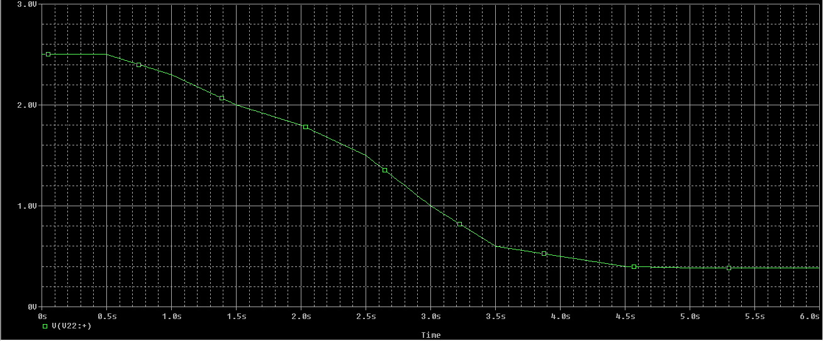

As the temperature decreases the output volatge at Vo2 decreases and this decreasing volatge is responsible for turning on the transistor and heater.

**Final Circuit Diagram:**

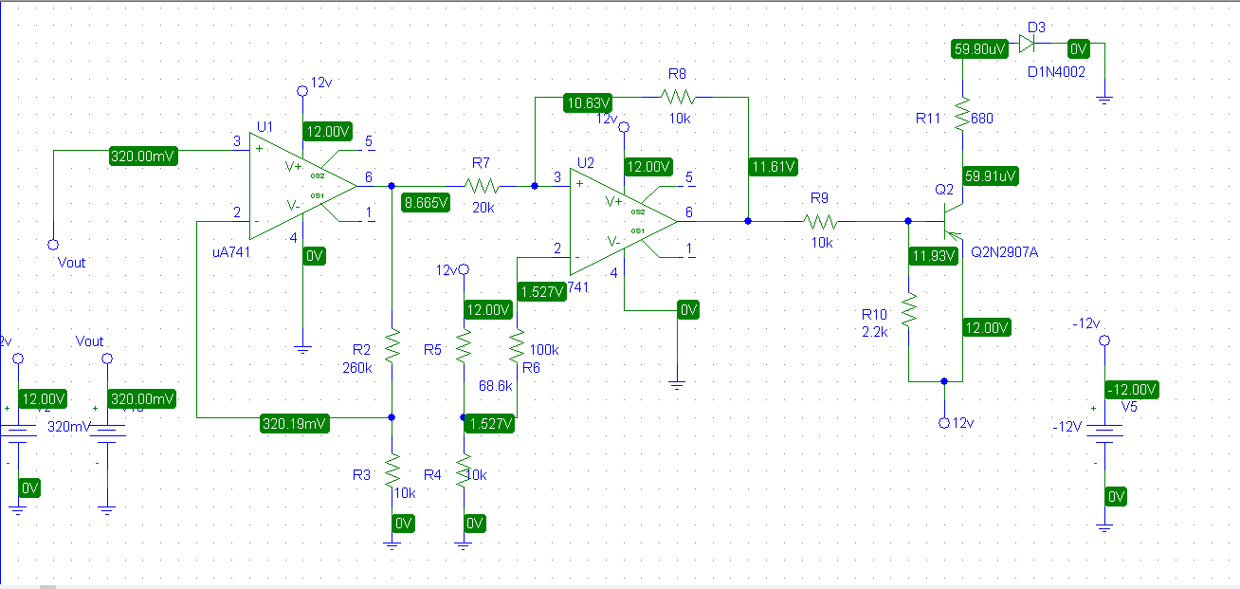

The above diagram explain the whole circuitry of thermistor and we can easily observe the values of resistors and opamps used as the diffrentila apmplifier and in the final stage the pnp transistor which turns on when the volatge below0.7 is applied to it and turn off when the greater volatge is applied to it.

**Conclusion:**

So we can conclude that by changing the values of R1,R2 and R3 we can design the thermistor of any range like for 32v and 40V or for 60v and 68V etc.This circuit diagram is describes the whole functioning and wrorking of the thermistor used in our daily life things like AC , heater s lamps and industrial firealaram systems.This can be improved and digitized as per our desire by adding some microcontroler with it so that its can be used as digital sensor.

**5):Reference:**

* Power Electronics EE 3305 Lecture Notes, Dr. Muhammad Abu-Khaizaran.
* Muhammad Rashid, “Power Electronics: Circuits, Devices and Applications”, 4 th ed. Prentice Hall, 2013.